**A**

**MINI PROJECT REPORT**

**ON**

**“MEASURING DIMENSION OF OBJECTS IN AN IMAGE USING COMPUTER VISION TECHNIQUE”**

*Submitted to* ***School of Engineering & Technology****,*

***ITM UNIVERSITY, GWALIOR*** *in Partial Fulfilment of the Requirements for the Second Year of* ***Bachelors of Technology*** *in* ***Computer Science & Engineering***

*By* -

***ANURAG KUMAR SAHU (BETN1CS19081)***

*Under the Guidance of –*

***(****Associate professor, CSA Dept.****)***



DEPARTMENT OF COMPUTER SCIENCE & ENGINEERING

SCHOOL OF ENGINEERING & TECHNOLOGY

**ITM UNIVERSITY, GWALIOR - 474001 MP, INDIA**

(NOV-2020)

**ITM UNIVERSITY, GWALIOR**

***(****Affiliated to All India Council of Technical Education****)***

**SCHOOL OF ENGINEERING & TECHNOLOGY**



**CERTIFICATE**

This is to certify that the Mini Project work entitled **“MEASURING DIMENSION OF OBJECTS IN AN IMAGE USING COMPUTER VISION TECHNIQUE”,** which is being submitted in partial fulfilment of the Requirements for the Second Year of **Bachelors of Technology** in **Computer Science & Engineering**Is the result of the work completed by –

**ANURAG KUMAR SAHU (BETN1CS19081*)***

Under my supervision and guidance

*Signature of Guide Signature of Co-guide*

**Guide Co-guide**

**DATE : DATE :**

**DECLARATION**

I with this declare that the work entitled **“MEASURING DIMENSION OF OBJECTS IN AN IMAGE USING COMPUTER VISION TECHNIQUE”** submitted to the Department of Computer Science & Engineering, School of Engineering and Technology, ITM University, Gwalior (M.P.) is our work done under the supervision of -----------. This work has not been previously formed the basis for the award of any degree/diploma/certificate nor has been submitted elsewhere for the award of any degree or diploma.

ANURAG KUMAR SAHU

**(Signature of the candidates)**

ANURAG KUMAR SAHU

**(Name of the candidates)**

(BETN1CS19081)

**(Roll Number of the candidates)**

**Verify by guide**

**ACKNOWLEDGEMENT**

We extend our sincere and heartfelt thanks to our esteemed **guide, ---------------** and for her exemplary guidance, monitoring and constant encouragement throughout the course at crucial junctures and for showing us the right way.

We would like to extend thanks to our respected ----------for allowing us to use facilities available. We would like to thank our faculty members also. Last but not the least,

We would like to thank our Mentors, friend and family members for the support and encouragement they have given us during the course of our work.

**ANURAG KUMAR SAHU**

**ABSTRACT**

In these days, real-time object detection and

dimensioning of objects is an important issue from many areas of

industry. This is a vital topic of computer vision problems. This

study presents an enhanced technique for detecting objects and

computing their measurements in real time from video streams.

We suggested an object measurement technique for real-time

video by utilizing OpenCV libraries and includes the canny edge

detection, dilation, and erosion algorithms. The suggested

technique comprises of four stages: (1) identifying an object to be

measured by using canny edge detection algorithm, (2) using

morphological operators includes dilation and erosion algorithm

to close gaps between edges, (3) find and sort contours, (4)

measuring the dimensions of objects. In the implementation of

the proposed technique, we designed a system that used OpenCV

software library, Raspberry Pi 3 and Raspberry Camera.

The

proposed technique was nearly achieved 98% success in

determines the size of the objects.

In these days, real-time object detection and

dimensioning of objects is an important issue from many areas of

industry. This is a vital topic of computer vision problems. This

study presents an enhanced technique for detecting objects and

computing their measurements in real time from video streams.

We suggested an object measurement technique for real-time

video by utilizing OpenCV libraries and includes the canny edge

detection, dilation, and erosion algorithms. The suggested

technique comprises of four stages: (1) identifying an object to be

measured by using canny edge detection algorithm, (2) using

morphological operators includes dilation and erosion algorithm

to close gaps between edges, (3) find and sort contours, (4)

measuring the dimensions of objects. In the implementation of

the proposed technique, we designed a system that used OpenCV

software library, Raspberry Pi 3 and Raspberry Camera.

The

proposed technique was nearly achieved 98% success in

determines the size of the objects.

In these days, real-time object detection and

dimensioning of objects is an important issue from many areas of

industry. This is a vital topic of computer vision problems. This

study presents an enhanced technique for detecting objects and

computing their measurements in real time from video streams.

We suggested an object measurement technique for real-time

video by utilizing OpenCV libraries and includes the canny edge

detection, dilation, and erosion algorithms. The suggested

technique comprises of four stages: (1) identifying an object to be

measured by using canny edge detection algorithm, (2) using

morphological operators includes dilation and erosion algorithm

to close gaps between edges, (3) find and sort contours, (4)

measuring the dimensions of objects. In the implementation of

the proposed technique, we designed a system that used OpenCV

software library, Raspberry Pi 3 and Raspberry Camera.

The

proposed technique was nearly achieved 98% success in

determines the size of the objects.

In these days, real-time object detection and

dimensioning of objects is an important issue from many areas of

industry. This is a vital topic of computer vision problems. This

study presents an enhanced technique for detecting objects and

computing their measurements in real time from video streams.

We suggested an object measurement technique for real-time

video by utilizing OpenCV libraries and includes the canny edge

detection, dilation, and erosion algorithms. The suggested

technique comprises of four stages: (1) identifying an object to be

measured by using canny edge detection algorithm, (2) using

morphological operators includes dilation and erosion algorithm

to close gaps between edges, (3) find and sort contours, (4)

measuring the dimensions of objects. In the implementation of

the proposed technique, we designed a system that used OpenCV

software library, Raspberry Pi 3 and Raspberry Camera.

The

proposed technique was nearly achieved 98% success in

determines the size of the objects.

In these days, real-time object detection and

dimensioning of objects is an important issue from many areas of

industry. This is a vital topic of computer vision problems. This

study presents an enhanced technique for detecting objects and

computing their measurements in real time from video streams.

We suggested an object measurement technique for real-time

video by utilizing OpenCV libraries and includes the canny edge

detection, dilation, and erosion algorithms. The suggested

technique comprises of four stages: (1) identifying an object to be

measured by using canny edge detection algorithm, (2) using

morphological operators includes dilation and erosion algorithm

to close gaps between edges, (3) find and sort contours, (4)

measuring the dimensions of objects. In the implementation of

the proposed technique, we designed a system that used OpenCV

software library, Raspberry Pi 3 and Raspberry Camera.

The

proposed technique was nearly achieved 98% success in

determines the size of the objects.

In these days, object detection and dimensioning of objects is an important issue from many areas of industry. This is a vital topic of computer vision problems. This study presents an enhanced technique for detecting objects and computing their measurements in frames captured by a smartphone’s camera. We suggested an object measurement technique for images by utilizing OpenCV libraries and includes the canny edge detection, dilation, and erosion algorithms. The suggested technique comprises of four stages:

(1) Identifying an object to be measured by using canny edge detection algorithm.

(2) Using morphological operators includes dilation and erosion algorithm to close gaps between edges.

(3) Find, sort and draw contours.

(4) Measuring the dimensions of objects.

In the implementation of the proposed technique, we designed a system that used OpenCV software library, Scipy, Numpy, imutils module and images captured by a Camera. The proposed technique was nearly achieved 98% success in determines the size of the objects.

In these days, real-time object detection and

dimensioning of objects is an important issue from many areas of

industry. This is a vital topic of computer vision problems. This

study presents an enhanced technique for detecting objects and

computing their measurements in real time from video streams.

We suggested an object measurement technique for real-time

video by utilizing OpenCV libraries and includes the canny edge

detection, dilation, and erosion algorithms. The suggested

technique comprises of four stages: (1) identifying an object to be

measured by using canny edge detection algorithm, (2) using

morphological operators includes dilation and erosion algorithm

to close gaps between edges, (3) find and sort contours, (4)

measuring the dimensions of objects. In the implementation of

the proposed technique, we designed a system that used OpenCV

software library, Raspberry Pi 3 and Raspberry Camera.

The

proposed technique was nearly achieved 98% success in

determines the size of the objects.

In these days, real-time object detection and

dimensioning of objects is an important issue from many areas of

industry. This is a vital topic of computer vision problems. This

study presents an enhanced technique for detecting objects and

computing their measurements in real time from video streams.

We suggested an object measurement technique for real-time

video by utilizing OpenCV libraries and includes the canny edge

detection, dilation, and erosion algorithms. The suggested

technique comprises of four stages: (1) identifying an object to be

measured by using canny edge detection algorithm, (2) using

morphological operators includes dilation and erosion algorithm

to close gaps between edges, (3) find and sort contours, (4)

measuring the dimensions of objects. In the implementation of

the proposed technique, we designed a system that used OpenCV

software library, Raspberry Pi 3 and Raspberry Camera.

The

proposed technique was nearly achieved 98% success in

determines the size of the objects.

In these days, real-time object detection and

dimensioning of objects is an important issue from many areas of

industry. This is a vital topic of computer vision problems. This

study presents an enhanced technique for detecting objects and

computing their measurements in real time from video streams.

We suggested an object measurement technique for real-time

video by utilizing OpenCV libraries and includes the canny edge

detection, dilation, and erosion algorithms. The suggested

technique comprises of four stages: (1) identifying an object to be

measured by using canny edge detection algorithm, (2) using

morphological operators includes dilation and erosion algorithm

to close gaps between edges, (3) find and sort contours, (4)

measuring the dimensions of objects. In the implementation of

the proposed technique, we designed a system that used OpenCV

software library, Raspberry Pi 3 and Raspberry Camera.

The

proposed technique was nearly achieved 98% success in

determines the size of the objects.

In these days, real-time object detection and

dimensioning of objects is an important issue from many areas of

industry. This is a vital topic of computer vision problems. This

study presents an enhanced technique for detecting objects and

computing their measurements in real time from video streams.

We suggested an object measurement technique for real-time

video by utilizing OpenCV libraries and includes the canny edge

detection, dilation, and erosion algorithms. The suggested

technique comprises of four stages: (1) identifying an object to be

measured by using canny edge detection algorithm, (2) using

morphological operators includes dilation and erosion algorithm

to close gaps between edges, (3) find and sort contours, (4)

measuring the dimensions of objects. In the implementation of

the proposed technique, we designed a system that used OpenCV

software library, Raspberry Pi 3 and Raspberry Camera.

The

proposed technique was nearly achieved 98% success in

determines the size of the objects.

In these days, real-time object detection and

dimensioning of objects is an important issue from many areas of

industry. This is a vital topic of computer vision problems. This

study presents an enhanced technique for detecting objects and

computing their measurements in real time from video streams.

We suggested an object measurement technique for real-time

video by utilizing OpenCV libraries and includes the canny edge

detection, dilation, and erosion algorithms. The suggested

technique comprises of four stages: (1) identifying an object to be

measured by using canny edge detection algorithm, (2) using

morphological operators includes dilation and erosion algorithm

to close gaps between edges, (3) find and sort contours, (4)

measuring the dimensions of objects. In the implementation of

the proposed technique, we designed a system that used OpenCV

software library, Raspberry Pi 3 and Raspberry Camera.

The

proposed technique was nearly achieved 98% success in

determines the size of the objects.

In these days, real-time object detection and

dimensioning of objects is an important issue from many areas of

industry. This is a vital topic of computer vision problems. This

study presents an enhanced technique for detecting objects and

computing their measurements in real time from video streams.

We suggested an object measurement technique for real-time

video by utilizing OpenCV libraries and includes the canny edge

detection, dilation, and erosion algorithms. The suggested

technique comprises of four stages: (1) identifying an object to be

measured by using canny edge detection algorithm, (2) using

morphological operators includes dilation and erosion algorithm

to close gaps between edges, (3) find and sort contours, (4)

measuring the dimensions of objects. In the implementation of

the proposed technique, we designed a system that used OpenCV

software library, Raspberry Pi 3 and Raspberry Camera.

The

proposed technique was nearly achieved 98% success in

determines the size of the objects.

In these days, real-time object detection and

dimensioning of objects is an important issue from many areas of

industry. This is a vital topic of computer vision problems. This

study presents an enhanced technique for detecting objects and

computing their measurements in real time from video streams.

We suggested an object measurement technique for real-time

video by utilizing OpenCV libraries and includes the canny edge

detection, dilation, and erosion algorithms. The suggested

technique comprises of four stages: (1) identifying an object to be

measured by using canny edge detection algorithm, (2) using

morphological operators includes dilation and erosion algorithm

to close gaps between edges, (3) find and sort contours, (4)

measuring the dimensions of objects. In the implementation of

the proposed technique, we designed a system that used OpenCV

software library, Raspberry Pi 3 and Raspberry Camera.

The

proposed technique was nearly achieved 98% success in

determines the size of the objects.

vIn these days, real-time object detection and

dimensioning of objects is an important issue from many areas of

industry. This is a vital topic of computer vision problems. This

study presents an enhanced technique for detecting objects and

computing their measurements in real time from video streams.

We suggested an object measurement technique for real-time

video by utilizing OpenCV libraries and includes the canny edge

detection, dilation, and erosion algorithms. The suggested

technique comprises of four stages: (1) identifying an object to be

measured by using canny edge detection algorithm, (2) using

morphological operators includes dilation and erosion algorithm

to close gaps between edges, (3) find and sort contours, (4)

measuring the dimensions of objects. In the implementation of

the proposed technique, we designed a system that used OpenCV

software library, Raspberry Pi 3 and Raspberry Camera.

The

proposed technique was nearly achieved 98% success in

determines the size of the objects.

In these days, real-time object detection and

dimensioning of objects is an important issue from many areas of

industry. This is a vital topic of computer vision problems. This

study presents an enhanced technique for detecting objects and

computing their measurements in real time from video streams.

We suggested an object measurement technique for real-time

video by utilizing OpenCV libraries and includes the canny edge

detection, dilation, and erosion algorithms. The suggested

technique comprises of four stages: (1) identifying an object to be

measured by using canny edge detection algorithm, (2) using

morphological operators includes dilation and erosion algorithm

to close gaps between edges, (3) find and sort contours, (4)

measuring the dimensions of objects. In the implementation of

the proposed technique, we designed a system that used OpenCV

software library, Raspberry Pi 3 and Raspberry Camera.

The

proposed technique was nearly achieved 98% success in

determines the size of the objects.

In these days, real-time object detection and

dimensioning of objects is an important issue from many areas of

industry. This is a vital topic of computer vision problems. This

study presents an enhanced technique for detecting objects and

computing their measurements in real time from video streams.

We suggested an object measurement technique for real-time

video by utilizing OpenCV libraries and includes the canny edge

detection, dilation, and erosion algorithms. The suggested

technique comprises of four stages: (1) identifying an object to be

measured by using canny edge detection algorithm, (2) using

morphological operators includes dilation and erosion algorithm

to close gaps between edges, (3) find and sort contours, (4)

measuring the dimensions of objects. In the implementation of

the proposed technique, we designed a system that used OpenCV

software library, Raspberry Pi 3 and Raspberry Camera.

The

proposed technique was nearly achieved 98% success in

determines the size of the objects.

In these days, real-time object detection and

dimensioning of objects is an important issue from many areas of

industry. This is a vital topic of computer vision problems. This

study presents an enhanced technique for detecting objects and

computing their measurements in real time from video streams.

We suggested an object measurement technique for real-time

video by utilizing OpenCV libraries and includes the canny edge

detection, dilation, and erosion algorithms. The suggested

technique comprises of four stages: (1) identifying an object to be

measured by using canny edge detection algorithm, (2) using

morphological operators includes dilation and erosion algorithm

to close gaps between edges, (3) find and sort contours, (4)

measuring the dimensions of objects. In the implementation of

the proposed technique, we designed a system that used OpenCV

software library, Raspberry Pi 3 and Raspberry Camera.

The

proposed technique was nearly achieved 98% success in

determines the size of the ob

**INDEX**

**CONTENTS**

**CERTIFICATE**…………………………………………………………………………………………………………………..1

**DECLARATION**………………………………………………………………………………………………………………. 2

**Acknowledgement**………………………………………………………………………………………………….……..3

**Abstract**…………………………………………………………………………………………………………………….……4

**List of Figures**……………………………………………………………………………………………………………….…5

**1. INTRODUCTION**……………………………………………………………………………………………….....7 - 8

1.1 The proposed methodology for object detection and dimension measurement.

**2. LITERATURE SURVEY**…………….…………………………………..…………………………………..…..9 - 18

2.1 Image Segmentation.

2.2 Edge Detection.

2.3 Edge Detecton Technique.

2.4 Conclusion.

**3. THEORETICAL CONCEPTS .**……………………………………..…………………………………………19 -

3.1 Digital Image Processing

3.2 What is an Image ?

3.3 Types of Images.

3.4 Image as a Matrix.

3.5 Phase in Image Processing.

3.6 Edge Detection

3.61 What is an Edge ?

3.62 Definiton of Edge Detection.

3.63 Goal of Edge Detection.

3.64 Edge Descriptors.

3.65 Edge Detection operators.

3.65.1 Sobel Operator

- Advantage

- Limitations

3.65.2 Prewitt Operator

- Advantage

- Limitations

3.65.3 Robert Operator

- Advantage

- Limitations

3.65.4 Laplacian of Gaussian (LoG) Operator

- Advantage

- Limitations

3.65.5 Canny Operator

- Advantage

- Limitations

3.7 Real world applications of Image Edge Detection.

**4. PRACTICAL IMPLEMENTATION.**……………………………………..…………………………………………

**5. EXPERIMENTAL OUTCOMES**…………………..…………………..…………………………………………**…**

**5. SYSTEM REQUIREMENTS….**………..…………………..………………………………………..…………**……**

**6. CONCLUSION .**…………………………………………..…………………..…………………………………………1

**CHAPTER – 1**

**INTRODUCTION**

Object detection and measurement systems are very vital tasks in the industrial process. Object detection is often used in product quality stages in the industry. The proposed system can be applied to an industrial quality control system. Likewise, it can be utilized for various industrial systems or for security purposes. Generally, it can be used in identifying objects in public area and measure dimensions of each of them.

The competence of the proposed system has been confirmed through utilizing frames or images captured by a camera. The execution of this procedure has a high computation rate and it is dependent on the resolution of frames. The achievement of identifying objects and separate these objects from the background is perfect.

To calculate the size of each object, firstly we need to determine the reference object. After that, the dimensions of the reference objects will be used to calculate the size of other objects. The reference object always is the left-most object in the image. Also, to calibrate your pixels per cm variable, the reference object can be utilized and from there, calculate the size of other objects in all frames. Completely computational procedures are assessed by passing an input image to our program. Every processes utilize the libraries of OpenCV.

We have found various papers attached to a measurement system. Each measurement applications are utilized for various purposes. A movable outdoor distance measurement system was proposed and 90% precision were obtained. For this purpose, a temperature reparation module was used to improve the accuracy. An ultrasonic distance measurement system was proposed for embedding distance measurement. The sizes of objects in an image are estimated by using computer vision methods.

**1.1 THE PROPOSED METHODOLOGY FOR OBJECT DETECTION AND DIMENSION MEASUREMENTS**

The system consists of two parts which are object detection and object measurement. In the first part, a camera is used to achieve the frames. In the second part, computer vision module will be applied to the captured frames to determine the objects, then, we will measure each object. The detected object of the current frame immediately will be processed to extract dimensions of objects. In the proposed system, firstly, we need to pre-process our image. The camera will capture a frame and the frame will convert to Gray scale and passed through the Gaussain filter to increase smoothness and accuracy. Objects are detected via canny edge detector algorithm. It is used to detect only one object or multiple objects. By the help of canny edge detector, the converted image will be processed. The canny edge algorithm scans the entire image. After that, execute dilation and erosion algorithm to close holes among edges in the edge frame. Figure 1, shows that the flow chart for the recommended system.

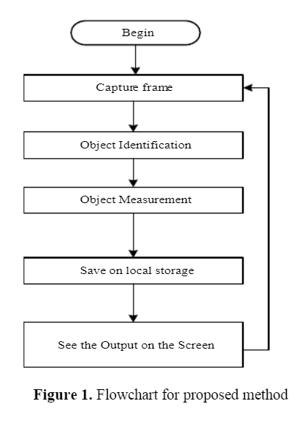

**CHAPTER – 2**

**LITERATURE SURVEY**

The edges of image have characterized the boundaries and regions of the image. Edges in images are areas with strong intensity contrasts – a jump in intensity from one pixel to the next. Edge detection is one of the most important tasks in image processing and image analysis. Edge detection process significantly reduces the amount of data and filter out the useless information while preserving important structural properties in an image. According to review work there are many ways to perform edge detection. In general the edge detection techniques are grouped into two categories:

* Gradient
* Laplacian

The edge detection process serves to simplify the analysis of images by drastically reducing the amount of data to be processed while at the same time preserving useful structural information about object boundaries. The filters are used in the process of identifying the image by locating the sharp edges which are discontinuous. These discontinuities bring changes in pixels intensities which define the boundaries of the object. The edge detection aims to identify points in a digital image at which the image brightness changes sharply or abruptly. Image edge detection mainly deals with extracting edges in an image by identifying pixels where the intensity variation is very high. Edges are used to measure the size of objects in an image; to isolate particular objects from their background to recognize or classify objects.

**2.1 IMAGE SEGMENTATION:** Segmentation subdivides an image into its constituent regions or objects. The level to which the subdivision is carried depends on the problem being solved. That is, segmentation should stop when the objects of interest in an application have been isolated.

Segmentation of nontrivial images is one of the most difficult tasks in image processing. Segmentation accuracy determines the eventual success or failure of computerized analysis procedures.

Image segmentation algorithms generally are based on one of two basic properties of intensity values:

1. Discontinuity 2. Similarity

In the first category, the approach is to partition an image based on abrupt changes in intensity, such as edges in an image.

The principal approaches in the second category are based on partitioning an image into regions that are similar according to a set of predefined criteria.

**Detection of Discontinuities:**

There are three basic types of discontinuities in an digital image:

* Points
* Lines
* Edges

**2.2 EDGE DETECTION:** Edge detection is the most common approach for detecting meaningful discontinuities in gray level. Different approaches are given for implementing first and second order digital derivatives for the detection of edges in an image. Various types of edges are shown in Figure below

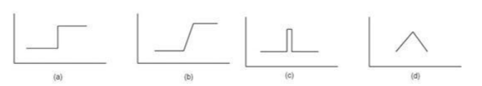

**Types of edges (a) Step edge (b) Ramp edge (c) Line edge (d) Roof edge**

Edges are represented in images as sudden disparities. An ideal edge would be a unit step from one pixel to the next. However, many factors must be taken into consideration:

* Noise
* Brightness of the image as a whole
* Corners
* Edge-like features

A problem of fundamental importance in image analysis is edge detection. Edges characterize object boundaries and are therefore useful for segmentation, registration, and identification of objects. A typical application where edge detection techniques are involved is automatic character recognition. Original Image Edge Detection.

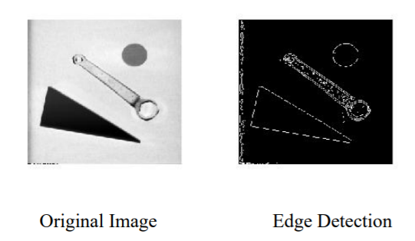

The three fundamental steps of edge detection:

* **Image Smoothing:** suppress as much noise as possible, without destroying the true edges.
* **Detection of edge points:** determine which edge pixels should be discarded as noise and which should be retained (usually, thresholding provides the criterion used for detection).
* **Edge localization:** determine the exact location of an edge (sub-pixel resolution might be required for some applications, that is, estimate the location of an edge to better than the spacing between pixels). Edge thinning and linking are usually required in this step.
  1. **EDGE DETECTION TECHNIQUES:**

Edge detection techniques are grouped into two categories:

* Gradient
* Laplacian

First-order derivatives in an image are computed using the gradient. Second-order derivatives are obtained using the Laplacian.

**Edge Detection using function Edge** **:**

The basic idea behind edge detection is to find places in an image where the intensity changes rapidly, using one of two general criteria:

1. Find places where the first derivative of the intensity is greater in magnitude than a specified threshold.

2. Find places where the second derivative of the intensity has a zero crossing. The general syntax for edge function is:

[g, t] = edge (f, ’method’ , parameters)

Where f is the input image, method is one of edge detection technique and parameters are additional parameters.

**Gradient:**

Edges in an image are pixel locations with abrupt changes in gray levels. In a continuous image (i.e., assuming continuous values), the derivative of the image f(x, y) assumes a local maximum in the direction of the edge. Therefore, one edge detection technique is to measure the gradient of f in a particular location. This is accomplished by using a gradient operator. Such operators, also called masks, provide finite-difference approximations of the orthogonal gradient vector fx and fy.

**Sobel Edge Detector:** The Sobel edge detector uses the masks shown in Figure below to approximate digitally the first derivatives Gx and Gy and finds edges using the Sobel approximation to the derivatives.

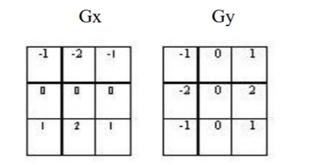

**The general calling syntax for the Sobel detector is**

**[g, t] = edge (f, ’sobel’, T, dir)**

Where f is the input image, T is a specified threshold, and dir specifies the preferred direction of the edges detected. ‘horizontal’, ‘vertical’ or ‘both’ (the default).

**Robert Edge Detector:**

The Roberts edge detector uses the masks in Fig. 3 to approximate digitally the first derivatives Gx and Gy.

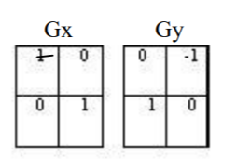

**Its general calling syntax is**

**[g, t] = edge (f, ‘Roberts’, T, dir)**

The parameters of this function are identical to the Sobel parameters. The Roberts detector is one of the oldest edge detectors in digital image processing.

**Prewitt Edge Detector:**

The Prewitt edge detector uses the masks in Figure below to approximate digitally the first derivatives Gx and Gy.

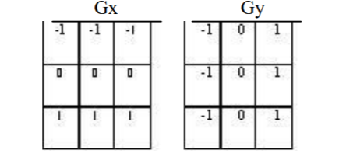

**Its general calling syntax is:**

**[g, t] = edge(f, ‘Prewitt’, T, dir)**

The parameters of this function are identical to the Sobel parameters. The Prewitt detector is slightly simpler to implement computationally than the Sobel detector, but it tends to produce somewhat noisier results.

**Laplacian:**

The gradients work best when the Gray level transition is quite abrupt. For smoother transitions, it is more advantageous to also compute the second-order derivative and to see when this second derivative crosses zero. If the second derivative crosses zero, it means that the location does indeed correspond to a maximum and therefore this pixel location is an edge location. This technique is called the zero-crossing edge location technique. A common mask operator for the estimation of the second derivative is the Laplacian operator.

**Laplacian of Gaussian (LoG):**

The Laplacian is a 2-D isotropic measure of the 2nd spatial derivative of an image. The image highlights regions of rapid intensity change and is therefore often used for edge detection. The Laplacian is often applied to an image that has first been smoothed with something approximating a Gaussian Smoothing filter in order to reduce its sensitivity to noise. The operator normally takes a single Gray level image as input and produces another gray level image as output.

**The general calling syntax for the LoG detector is:**

**[g, t] = edge (f, ’log’, T, sigma)**

Where sigma is the standard deviation.

**Zero Crossing:**

It uses second derivative and it includes Laplacian operator. This is sensitive to noise. Haralick proposed the use of zero crossing of the second directional derivative of the image intensity function.

**The general calling syntax is:**

**[g, t] = edge (f, ’zero cross’, T, H)**

Where H is the filter function.

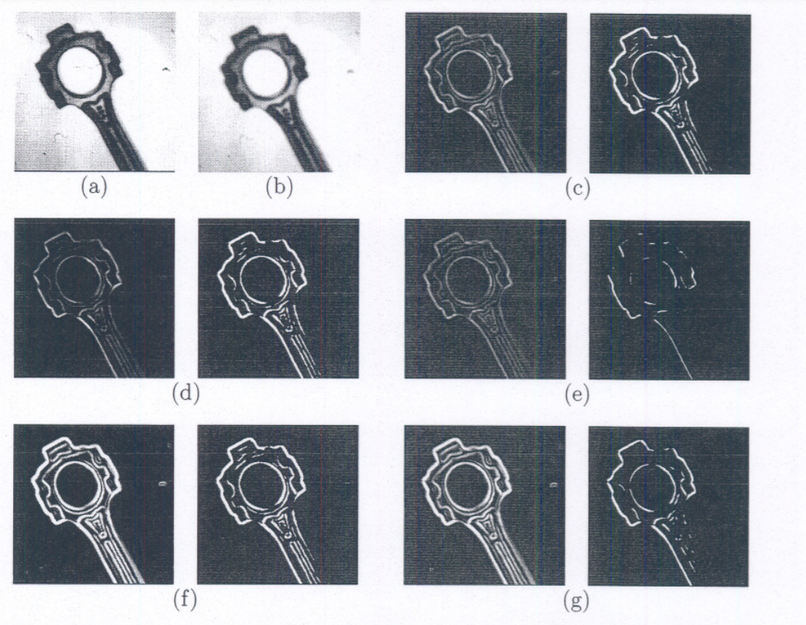

**A Comparion of various Edge Detectors with filtering (a) Original Image (b) Filtered Image (c) Simple Gradient Using 1**X**2 and 2**X**1 masks, T=32 (d) Gradient Using 2**X**2 masks, T=64 (e) Robert Cross Operator, T=64 (f) Sobel, T=225 (g) Prewitt Operator, T=225**

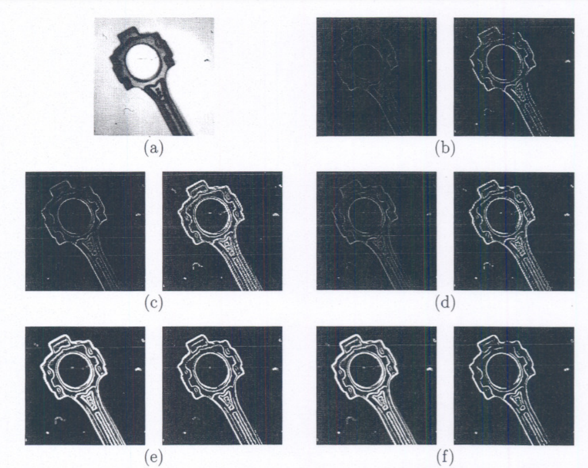

**A Comparion of various Edge Detectors without filtering (a) Original Image (b) Simple Gradient Using 1**X**2 and 2**X**1 masks, T=64 (c) Gradient Using 2**X**2 masks, T=64 (d) Robert Cross Operator, T=64 (e) Sobel, T=225**

**(f) Prewitt Operator, T=225**

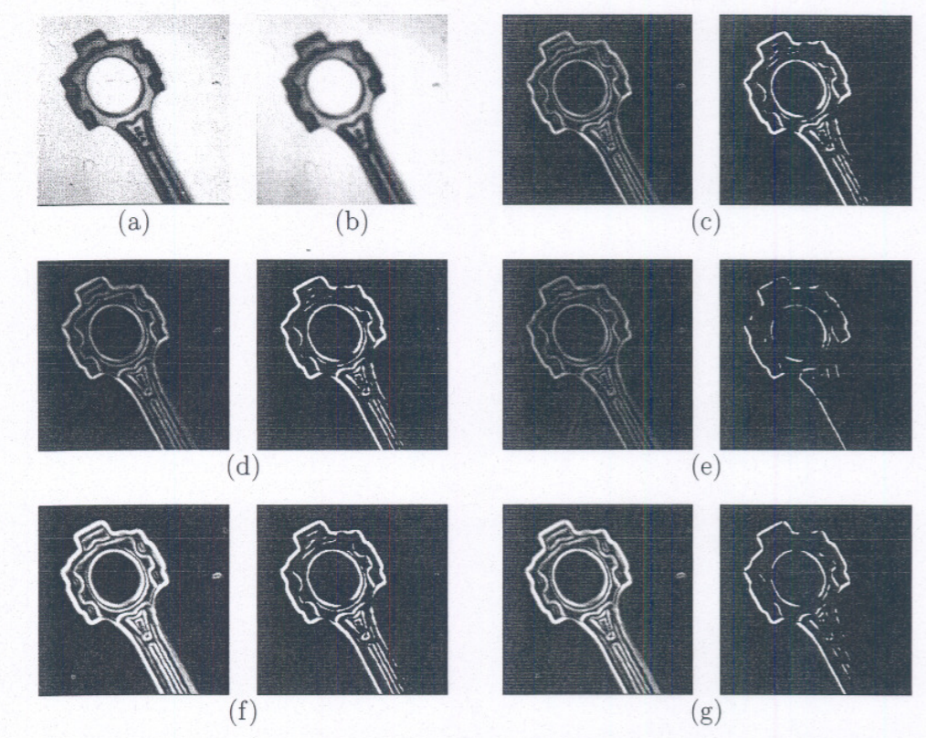

**A Comparion of various Edge Detectors on a noisy image. (a) Noisy Image (b) Filtered Image (c) Simple Gradient Using 1**X**2 and 2**X**1 masks, T=32 (d) Gradient Using 2**X**2 masks, T=64 (e) Robert Cross Operator, T=64 (f) Sobel, T=225 (g) Prewitt Operator, T=225**

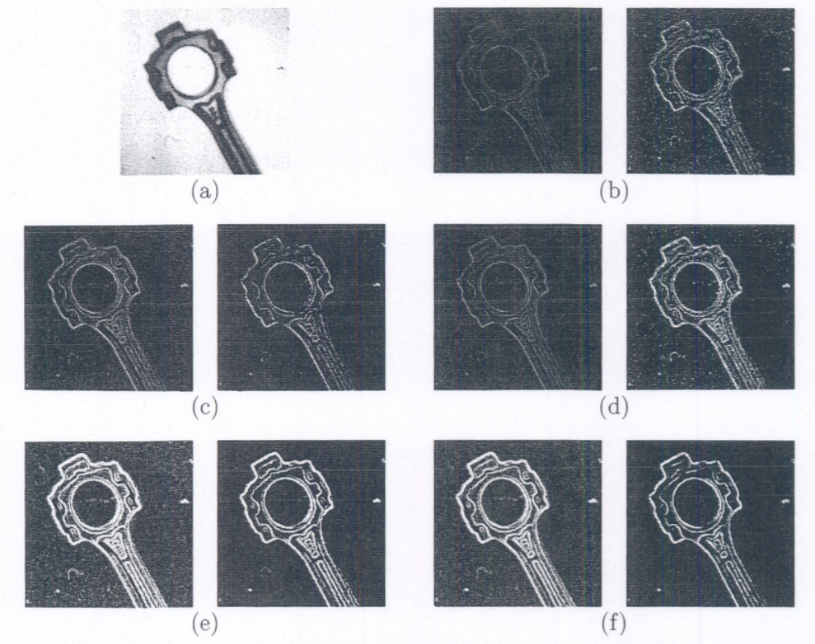

**A Comparion of various Edge Detectors on a noisy image without filtering (a) Noisy Image (b) Simple Gradient Using 1**X**2 and 2**X**1 masks, T=64 (c) Gradient Using 2**X**2 masks, T=128 (d) Robert Cross Operator, T=64 (e) Sobel, T=225 (f) Prewitt Operator, T=2**

**2.4 CONCLUSIONS:**

This paper presents a review on various edge detection techniques like gradient-based and Laplacian -based techniques. Edge detection is a significant task for image segmentation used for object detection and many other applications. First-order derivatives in an image are computed using the gradient. Second-order derivatives are obtained using the Laplacian Result of edge detection techniques vary from set of images.

**CHAPTER – 3**

**THEORETICAL CONCEPTS**

* 1. **Introduction to Digital Image Processing –**

Digital Image Processing means processing digital image by means of a digital computer. We can also say that it is a use of computer algorithms, in order to get enhanced image either to extract some useful information.

**Image processing mainly include the following steps:**

1. Importing the image via image acquisition tools.  
2. Analysing and manipulating the image.  
3. Output in which result can be altered image or a report which is based on analysing that image.

**3.2 What is an Image?**

An image is defined as a two-dimensional function, **F(x, y)**, where x and y are spatial coordinates, and the amplitude of **F** at any pair of coordinates (x, y) is called the **intensity** of that image at that point. When x, y and amplitude values of **F** are finite, we call it a **digital image**.  
In other words, an image can be defined by a two-dimensional array specifically arranged in rows and columns.  
Digital Image is composed of a finite number of elements, each of which elements have a particular value at a particular location. These elements are referred to as ***picture elements, image elements, and pixels***. A *Pixel* is most widely used to denote the elements of a Digital Image.

**3.3 Types of an Image –**

1. **BINARY IMAGE –** The binary image as its name suggests, contain only two pixel elements i.e, 0 & 1, where 0 refers to black and 1 refers to white. This image is also known as Monochrome.
2. **BLACK AND WHITE IMAGE**– The image which consist of only black and white colour is called BLACK AND WHITE IMAGE.
3. **8 bit COLOR FORMAT**– It is the most famous image format. It has 256 different shades of colours in it and commonly known as Grayscale

Image. In this format, 0 stands for Black, and 255 stands for white, and 127 stands for gray.

1. **16 bit COLOR FORMAT**– It is a colour image format. It has 65,536 different colours in it. It is also known as High Colour Format. In this format the distribution of colour is not as same as Grayscale image.

A 16 bit format is actually divided into three further formats which are Red, Green and Blue.

**3.4 Image as a Matrix –**

As we know, images are represented in rows and columns we have the following syntax in which images are represented:

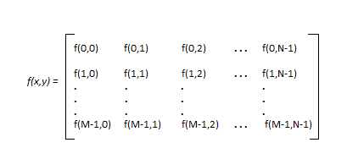

The right side of this equation is digital image by definition. Every element of this matrix is called ***image element, picture element or pixel.***

**3.5 Phase in Image Processing *-***

1. **ACQUISITION** – It could be as simple as being given an image which is in digital form. The main work involves:  
a) Scaling  
b) Colour conversion(RGB to Gray or vice-versa)

2. **IMAGE ENHANCEMENT**– It is amongst the simplest and most appealing in areas of Image Processing it is also used to extract some hidden details from an image and is subjective.

3. **IMAGE RESTORATION**– It also deals with appealing of an image but it is objective (Restoration is based on mathematical or probabilistic model or image degradation).

4. **COLOR IMAGE PROCESSING**– It deals with Pseudocolour and full colour image processing colour models are applicable to digital image processing.

5. **WAVELETS AND MULTI-RESOLUTION PROCESSING**– It is foundation of representing images in various degrees.

6. **IMAGE COMPRESSION**-It involves in developing some functions to perform this operation. It mainly deals with image size or resolution.

7. **MORPHOLOGICAL PROCESSING**-It deals with tools for extracting image components that are useful in the representation & description of shape.

8. **SEGMENTATION PROCEDURE**-It includes partitioning an image into its constituent parts or objects. Autonomous segmentation is the most difficult task in Image Processing.

9. **REPRESENTATION & DESCRIPTION**-It follows output of segmentation stage, choosing a representation is only the part of solution for transforming raw data into processed data.

10. **OBJECT DETECTION AND RECOGNITION**-It is a process that assigns a label to an object based on its descriptor.

**3.6 Edge Detection:**

**3.61 What is an Edge?**

Edges are significant local changes of intensity in a digital image. An edge can be defined as a set of connected pixels that forms a boundary between two disjoint regions. There are three types of edges:

* Horizontal edges
* Vertical edges
* Diagonal edges

**3.62 Definition of Edge Detection –**

**Edge Detection** is a method of segmenting an image into regions of discontinuity. It is a widely used technique in digital image processing like

* pattern recognition
* image morphology
* feature extraction

Edge detection allows users to observe the features of an image for a significant change in the Gray level. This texture indicating the end of one region in the image and the beginning of another. It reduces the amount of data in an image and preserves the structural properties of an image.

**3.63 Goal of Edge Detection –**

- Produce a line drawing of a scene from an image of that scene.

- Important features can be extracted from the edges of an image (e.g., corners, lines, curves).

- These features are used by higher-level computer vision algorithms (e.g., recognition)

.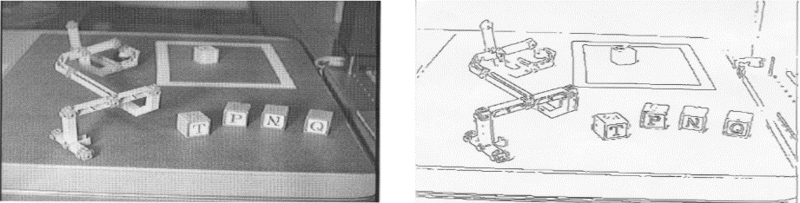

**3.64 Edge Descriptors –**

**Edge Normal:** unit vector in the direction of maximum intensity change.

**Edge direction:** unit vector to perpendicular to the edge normal.

**Edge position or center:** The image position at which the edge is located. Edge strength: related to the local image contrast along the normal.

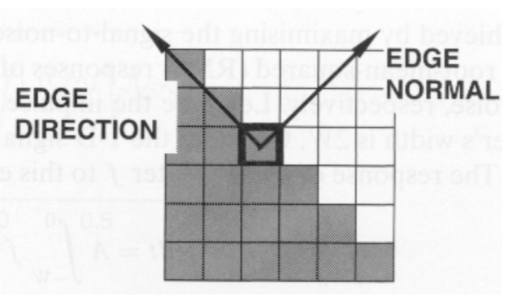

**3.65 Edge Detection operator –**

**Edge Detection Operators** are of two types:

* **Gradient –** based operator which computes first-order derivations in a digital image like, Sobel operator, Prewitt operator, Robert operator.
* **Gaussian –** based operator which computes second-order derivations in a digital image like, Canny edge detector, Laplacian of Gaussian.

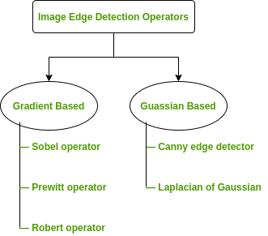

**3.65.1 Sobel Operator:**

It is a discrete differentiation operator. It computes the gradient approximation of image intensity function for image edge detection. At the pixels of an image, the Sobel operator produces either the normal to a vector or the corresponding gradient vector. It uses two 3 x 3 kernels or masks which are convolved with the input image to calculate the vertical and horizontal derivative approximations respectively –

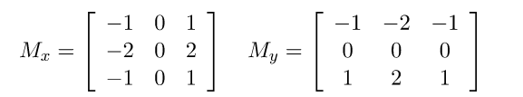

**Advantages:** 

1. Simple and time efficient computation.
2. Very easy at searching for smooth edges.

**Limitations:** 

1. Diagonal direction points are not preserved always.
2. Highly sensitive to noise.
3. Not very accurate in edge detection.
4. Detect with thick and rough edges does not give appropriate results.

**3.65.2 Prewitt Operator:**

This operator is almost similar to the sobel operator. It also detects vertical and horizontal edges of an image. It is one of the best ways to detect the orientation and magnitude of an image. It uses the kernels or masks –

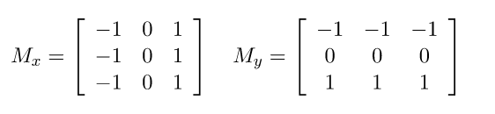

**Advantages:**

1. Good performance on detecting vertical and horizontal edges.
2. Best operator to detect the orientation of an image.

**Limitations:**

1. The magnitude of coefficient is fixed and cannot be changed.
2. Diagonal direction points are not preserved always.

**3.65.3 Robert Operator:**

This gradient-based operator computes the sum of squares of the differences between diagonally adjacent pixels in an image through discrete differentiation. Then the gradient approximation is made. It uses the following 2 x 2 kernels or masks –

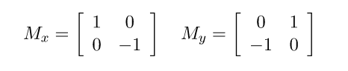

**Advantages:**

1. Detection of edges and orientation are very easy.
2. Diagonal direction points are preserved.

**Limitations:**

1. Very sensitive to noise.
2. Not very accurate in edge detection.

**3.65.4 Marr-Hildreth Operator or Laplacian of Gaussian (LoG):**

It is a Gaussian - based operator which uses the Laplacian to take the second derivative of an image. This really works well when the transition of the grey level seems to be abrupt. It works on the zero-crossing method i.e when the second-order derivative crosses zero, then that particular location corresponds to a maximum level. It is called an edge location. Here the Gaussian operator reduces the noise and the Laplacian operator detects the sharp edges.   
The Gaussian function is defined by the formula:

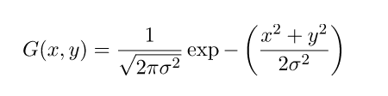

Where

Sigma is the standard deviation and the LoG operator is computed from

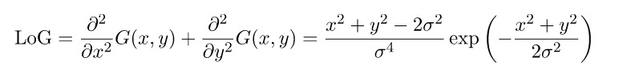

**Advantages:**

1. Easy to detect edges and their various orientations.
2. There is fixed characteristics in all directions.

**Limitations:**

1. Very sensitive to noise.
2. The localization error may be severe at curved edges.
3. It generates noisy responses that do not correspond to edges, so-called “false edges”.

**3.65.5 Canny Operator:**

It is a Gaussian based operator in detecting edges. This operator is not susceptible to noise. It extracts image features without affecting or altering the feature. Canny edge detector have advanced algorithm derived from the previous work of Laplacian of Gaussian operator. It is widely used an optimal edge detection technique. It detects edges based on three criteria:

1. Low error rate.
2. Edge points must be accurately localized.
3. There should be just one single edge response.

**Advantages:** 

1. It has good localization
2. It extract image features without altering the features
3. Less Sensitive to noise

**Limitations:**

1. There is false zero crossing
2. Complex computation and time consuming
   1. **Some Real-world Applications of Image Edge Detection:**
3. Medical imaging, study of anatomical structure.
4. Locate an object in satellite images.
5. Automatic traffic controlling systems.
6. Face recognition, and fingerprint recognition.

**CHAPTER – 4**

**PRACTICAL IMPLEMENTATION**

shows the input frame that used for canny edge

detection. First stage in canny edge detector algorithm is

delete the noise in the frames by applying a Gaussian filter.

The frame after converting to gray scale and apply Gaussian

filter is appeared in Figure 3.

Figure 2, shows the input frame that used for canny edge detection. First stage in canny edge detector algorithm is delete the noise in the frames by applying a Gaussian filter. The frame after converting to gray scale and apply Gaussian filter is appeared in Figure 3.

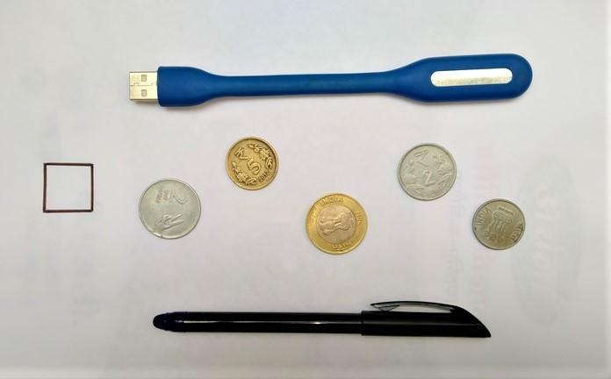

**Figure 2 Input frame**

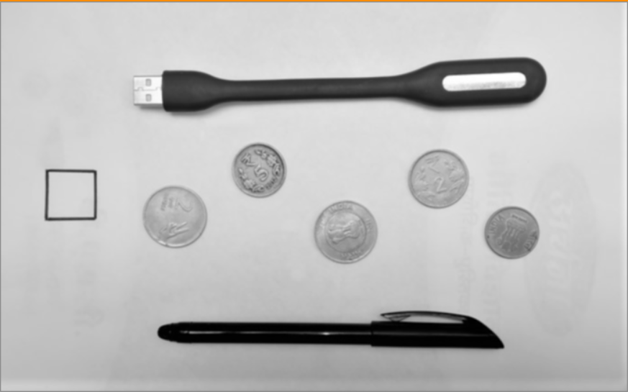

**Figure 3 Grayscale & Smoothed input Frame**

In the compute gradient stage, we detect the edge gradient and direction for each pixel. For define the gradient at every pixel of smoothened frame, Sobel operator utilized.

A complete scan of frame will be done afterward receiving gradient magnitude and direction, to eliminate any undesirable pixels which might not establish the edge. In this stage, just local maxima must be considered as edges through applying Non-maximum suppression. Non-maximum suppression exchanges the smoothed edges in the frame of the gradient magnitudes to sharp edges. Non-maximum suppression is carried out to keep every local maximum in the gradient picture, and removing the whole thing else.

The final stage of canny edge detector algorithm is hysteresis thresholding. This stage selects which are every edges are surely edges and which aren’t edges. The two threshold values are empirically selected and their definition will upon on the content of a given frame. This is achieved via choosing big and small threshold values. If Edge pixels stronger than the big threshold, it is marked such as sturdy. Strong edges will be measured as the last edges. Also, edge pixel will be suppressed If an edge pixels weaker than the small threshold, and it is marked as weak edge if an edge pixel among the big and small thresholds.

To obtain the better result and more accurate object detection, the canny edge detection procedure has been improved with some Morphological operations. These procedures are commonly a combination of nonlinear procedures performed relatively on the preparation of pixels without changing their numeral values. Erosion and dilation are the keys for morphological operations. In this study, a morphological process is performed such as a mixture of dilation and erosion. The opening is the initial procedure in which erosion is followed through dilation. Closing is the second operation in which dilation is followed through erosion. As a mixture of these processes we are capable to acquire superior determination for discovery edges in-depth frame. Figure 4, 5 and 6 shows that the frame after applying Canny edge detection algorithm, dilation and erosion operation repectively.

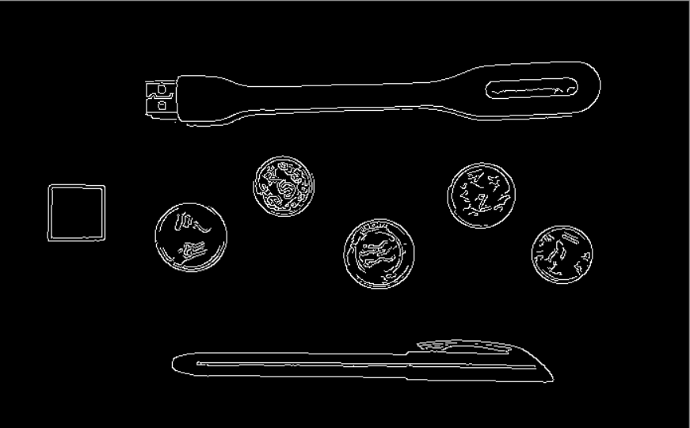

**Figure 4 Input Frame after apply Canny Edge Detection**

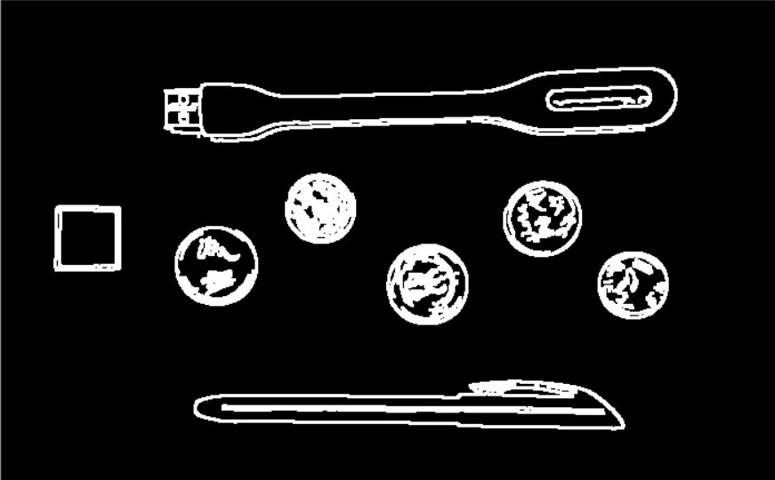

**Figure 5 Input Frame after apply Dilation Operation**

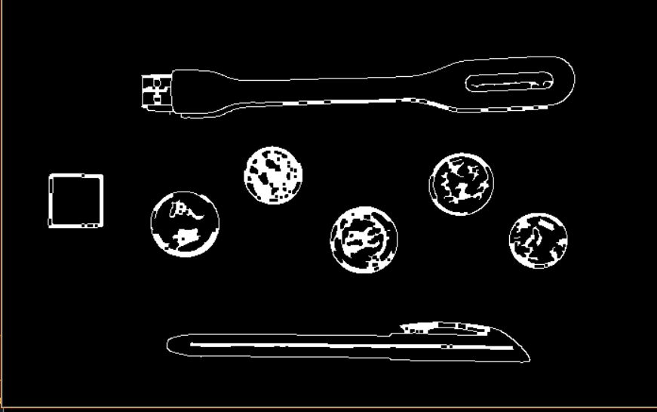

**Figure 6 Input Frame after apply Erosion Operation**

To briefly summarize object measurement, after edge detection and close any gaps between edges, we detect contours by using an OpenCV function that is cv2.findContours to find the shapes of the objects in the edge map. We arrange contours from left to right. The reference object in the frame is permanently the left one. By depending to the reference object, Next, we scan every contours, begin looping above every individual contours. After that, the rectangle around objects will be drawn in black. So, the points of the bounding box rectangle will draw in a small red colour. After that, we can get blue midpoints because the bounding box is ordered. Finally, we calculate pixels Per cm variable through dependence on reference object. The height-distance in pixels will put on dA (height) variable and width distance will put on dB (width) variable. Then, we calculated the Euclidean distance among sets of center points.

**CHAPTER – 5**

**EXPERIMENTAL OUTCOME**

Figure 7, illustrates the object detection and measurements. The size of each object in the frame which are calculated.

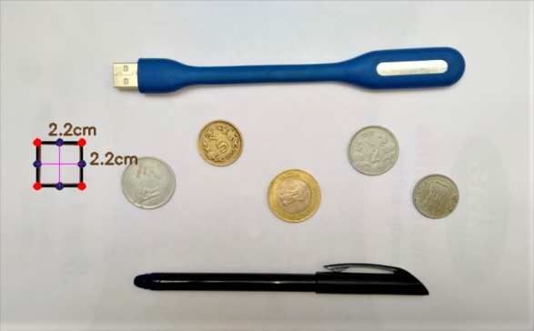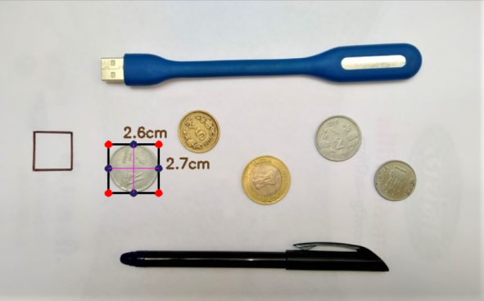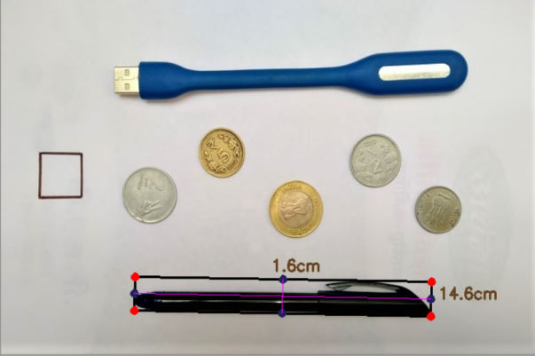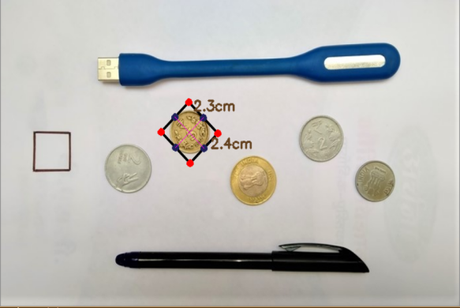

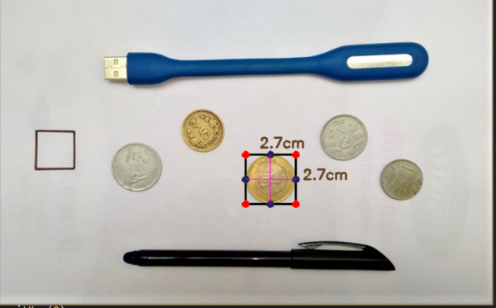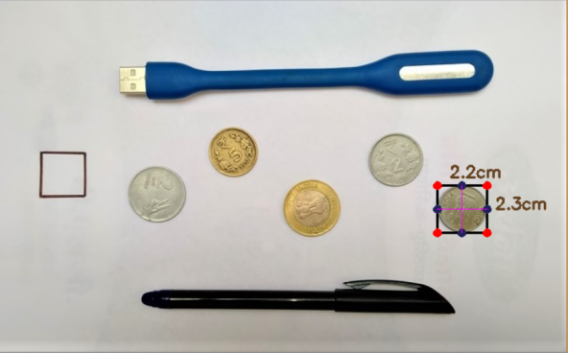

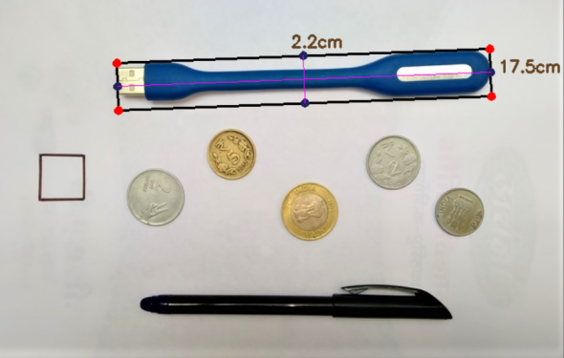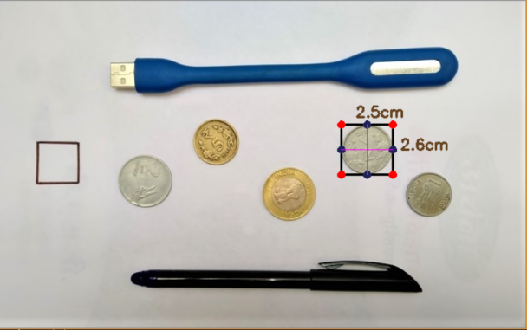

**Figure 7 Calculate the size of objects**

In this experiment we first measured size of objects such as square box, some of the coins, pen, light. Table 1, shows the accuracy of proposed object measurement system for these objects. Abbreviations in the table are as follows;

**AM-H: Actual Measure-Height.**

**PM-H: Proposed Measure-Height.**

**AM-W: Actual Measure-Width.**

**PM-W: Proposed Measure-Width.**

**TABLE 1: ACCURACY OF THE EXPERIMENT 1**

|  |  |  |  |  |  |
| --- | --- | --- | --- | --- | --- |
| **NAME OF OBJECTS** | **AM-H**  **CM** | **AM-W**  **CM** | **PM-H**  **CM** | **PM-W**  **CM** | **ACCURACY**  **(%)** |
| Square Box(Reference Object) | 2.2 | 2.2 | 2.2 | 2.2 | 100% |
| 2 Rupees coin old | 2.8 | 2.8 | 2.6 | 2.7 | 99.997% |
| Pen | 1.6 -1.7 | 14.6-14.7 | 1.6 | 14.6 | 99.999% |
| 5 Rupees coin | 2.4 | 2.4 | 2.3 | 2.4 | 99.999% |
| 10 Rupees coin | 2.8 | 2.8 | 2.7 | 2.7 | 99.998% |
| 1 Rupees coin | 2.3 | 2.3 | 2.2 | 2.3 | 99.999% |
| Light | 2.2 | 17.4 | 2.2 | 17.5 | 99.999% |
| 2 Rupees coin new | 2.6 | 2.6 | 2.5 | 2.6 | 99.999% |

**Average Accuracy in the Experiment No.1 99.99875%.**

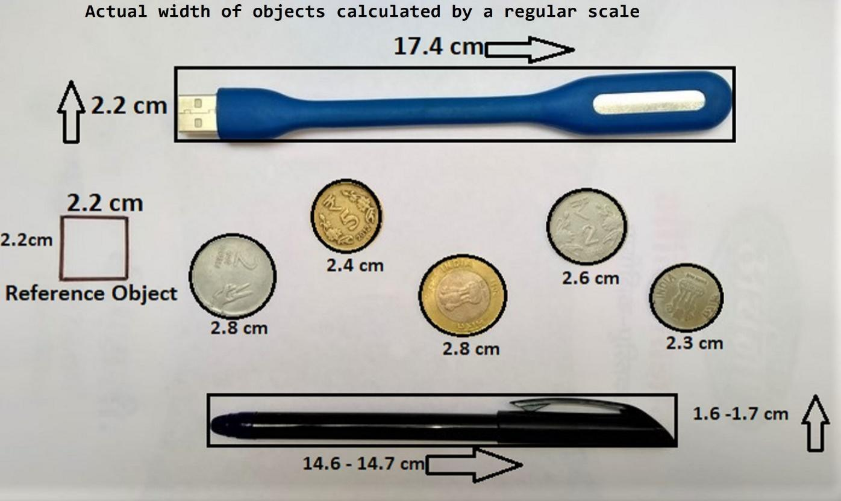

Figure 8, illustrates the object detection and measurements. The size of each object in the frame which are calculated.

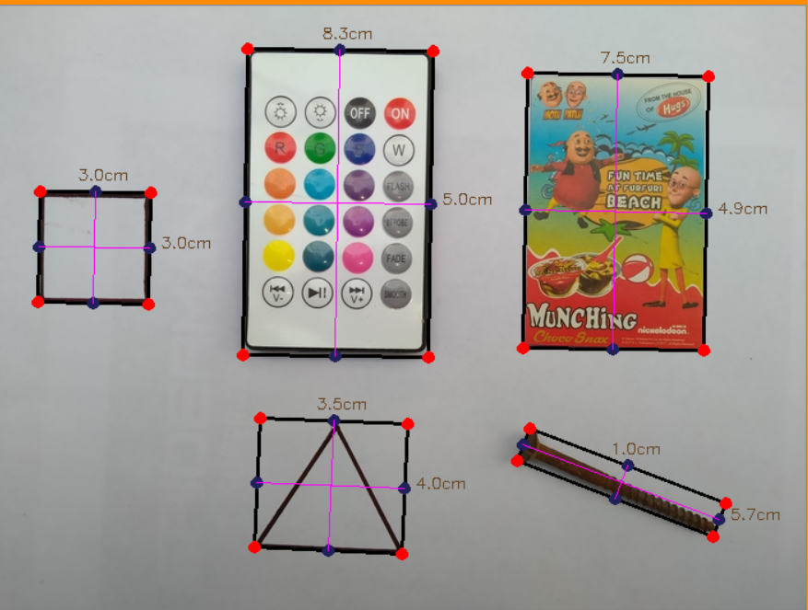

**Figure 8 Calculate the size of objects**

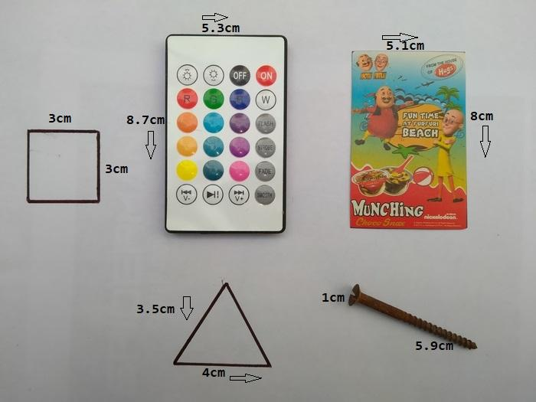

**TABLE 2: ACCURACY OF THE EXPERIMENT 2**

|  |  |  |  |  |  |
| --- | --- | --- | --- | --- | --- |
| **NAME OF OBJECTS** | **AM-H**  **CM** | **AM-W**  **CM** | **PM-H**  **CM** | **PM-W**  **CM** | **ACCURACY**  **(%)** |
| Square Box(Reference Object) | 3.0 | 3.0 | 3.0 | 3.0 | 100% |
| Remote | 8.7 | 5.3 | 8.3 | 5.0 | 99.993% |
| Card | 8.0 | 5.1 | 7.5 | 4.9 | 99.993% |
| Triangle | 3.5 | 4.0 | 3.5 | 4.0 | 100% |
| Nail | 5.9 | 1.0 | 5.7 | 1.0 | 99.998% |

**Average Accuracy in the Experiment No.2 99.9968%.**

Nevertheless, not every results are perfect, since this is due to the seeing angle and lens deformation. By calibrate the camera and set good width parameter, then accuracy will be increase.

**CHAPTER – 6**

**SYSTEM REQUIREMENTS**

1) Install python 3.x version on your computer.

2) Install openCV and It’s dependencies like Numpy, Scipy etc.

* 1. **STEPS TO BE FOLLOWED:**

1) Download and install python 3.x version from official python language website. <https://www.python.org/downloads/>

2) Install the following dependencies via pip.

* **Numpy:(>=1.17.3)**

Numpy is library of python programming language, adding support for large, multi-dimensional array and matrices along with large collection of high level mathematical functions to operate over these arrays. The ancestors of Numpy, was originally created by Jim Hugunin with contributions from several developers. In 2005 Travis Oliphant created Numpy for incorporating features of computing Numarray into numeric, with extension modification. Numpy is Open source software and has many contributors.

**Command :** Pip install numpy.

* **Scipy:**

Scipy contains module for many optimizations, linear algebra, integration, interpolation, special function, FFT, signal and image processing, ODE solvers and other tasks common in Engineering.

Scipy abstracts majorly on Numpy array objects, and is the art of the Numpy stack which include tools like Matplotlib, pandas and sympy etc., and an expanding set of scientific computing libraries. This Numpy stack has similar uses to other applications such as MATLAB, Octave and Scilib. The Numpy stack is also sometimes referred as the Scipy stack.

The Scipy library is currently distributed under BSD License, and it’s development is sponsored and supported by an open communities of developers. It is also supported by NumFOCUS, community foundation for supporting reproducible and accessible science.

**Command :** Pip install scipy.

* **openCV: (1.18.5)**

openCV is an library of programming functions mainly aimed on real time computer vision originally developed by Intel. It is later supported by Willow Garage then by Itseez. This library is cross platform and easy to use under the open source BSD License.

**Command :** Pip install openCV-python

**CHAPTER – 7**

**CONCLUSION**

In This study, a powerful object measurement method is proposed for industrial systems. In the offered system, Computer Vision used to detect and measure objects. This system can also enhanced by using Raspberry Pi 3 camera to detect and measure objects in a real time video. After the object has been detected by using canny edge detector, the size is obtained for each object by using OpenCV functions. We enhanced the canny edge detector algorithm through utilizing Morphological operations. This procedure benefits to eliminate extra noises. Furthermore, whereas eliminating the extra noises it likewise smoothens the shape and keeps the outline and size of each object. Thus, the outlines of the different objects in the scene were kept. The proposed technique works fine since it has very great features.